Impact of Aid on World-Wide Food Security

Results and Analysis Report

Vlad Agache, Adrian Baniak, Kshitji Gupta, Rui Janson, Binghao Zhang

Group 5



# Introduction to the Problem

Food security remains a world-wide challenge, which appears to be on the rise, despite a steady decline for over a decade. In 2016, an additional 38 million people became undernourished, indicating that food security is a continuing challenge (Food and Agriculture Organization of the United Nations, 2017).

Foreign aid is a common tool deployed by developed notions and agencies to combat food security issues. This analysis will explore the efficacy of aid in reducing food security challenges, determine if other factors play an important role in food security issues and assess to what extent public awareness of food security impact aid levels by donor countries.

# Effectiveness of External Aid in Addressing Food Security Issues

Analysis in this section focuses on establishing to what extent external aid affects food security. Correlations between aid levels and food security indicators will be established on a country-by-country basis to evaluate the effectiveness of aid. Further models are developed to determine if specific forms of aid are more effective in addressing food security issues than others.

## 2.1 Data Sources and Processing

Data for this analysis was obtained through the World Bank Database (The World Bank, 2017), which aggregates various data sources. The data retrieved included the following:

Measures of External Aid

* Net official development assistance and official aid received (current US$)
* Net ODA received per capita (current US$)
* Debt forgiveness grants (current US$)
* Grants, excluding technical cooperation (BoP, current US$)

Food Security Indicators

* Prevalence of undernourishment (% of population)
* Depth of the food deficit (kilocalories per person per day)

World Bank data from 1960 to 2015 was processed to remove 46 non-country entities which were present as aggregates (e.g. Arab World, Middle Income Nations, etc). A total of 217 countries were analyzed, starting from year 2000 and ending in 2015, the latest year for which complete data was available. The last 16 years of available data was chosen in order to capture the changing dynamic in food security issues which have occurred over the past decade, such as the devastation of Haiti following the 2010 earthquake, and the continuing war in Afghanistan and the Middle East.

## 2.2 Analysis and Results – Effectiveness of External Aid on Reducing Food Security Issues

Correlations between the amount of aid received (both total aid and per capita) and food security indicators were obtained for each country. In this analysis, Spearman’s correlation coefficient is chosen as an appropriate measure, rather than the more widely used Pearson coefficient, since we are not interested in testing if there is a strictly linear relationship between aid and food security indicators. As shown in Figure 1, potential relationships between aid and food security indicators may not be linear, and may follow complex patterns, justifying the use of Spearman’s correlation coefficient.

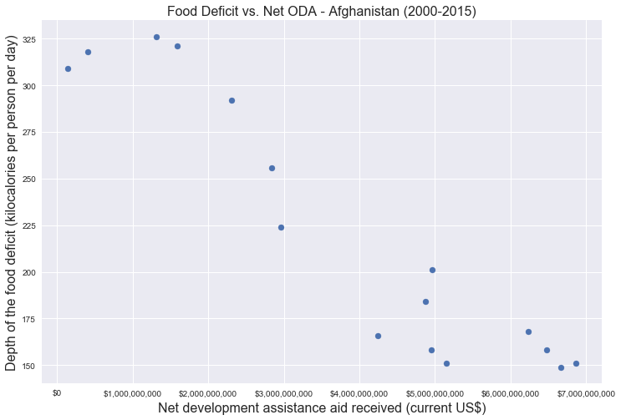

Figure 2‑1. Relationship between Depth of Food Deficit and Net ODA received for Afghanistan from 2000 to 2015

Correlation results for the first 10 countries ranked by average food deficit and undernourishment are provided in Figure 2 and Figure 3.

|  |  |  |  |  |
| --- | --- | --- | --- | --- |
|  |  | **ODA per Capita vs Food Deficit** | **Total ODA vs Food Deficit** |  |
| Rank | **Country Name** | **Spearman Coefficient** | **Spearman Coefficient** | **Average Food Deficit (2000-2015)** |
| 1 | Haiti | -0.546 | -0.564 | 542.75 |
| 2 | Zambia | 0.068 | 0.468 | 401.1875 |
| 3 | Rwanda | -0.761 | -0.882 | 340.9375 |
| 4 | Ethiopia | -0.794 | -0.871 | 335 |
| 5 | Korea, Dem. People’s Rep. | 0.142 | 0.197 | 308.6875 |
| 6 | Zimbabwe | -0.915 | -0.965 | 305.625 |
| 7 | Central African Republic | -0.521 | -0.533 | 300.375 |
| 8 | Chad | 0.373 | 0.367 | 298.4375 |
| 9 | Tajikistan | -0.084 | -0.118 | 294.0625 |
| 10 | Liberia | -0.140 | -0.208 | 292.5 |

Figure 2‑2. Correlations between aid and food deficit for the 10 countries with highest average food deficits between 2000-2015. Highlighted entries represent non-significant correlations at a significance of 0.05.

|  |  |  |  |  |
| --- | --- | --- | --- | --- |
|  |  | **ODA per capita vs Undernourishment** | **Total ODA vs Undernourishment** |  |
| Rank | **Country Name** | **Spearman Coefficient** | **Spearman Coefficient** | **Average Undernourishment (2000-2015)** |
| 1 | Haiti | -0.821 | -0.815 | 54 |
| 2 | Zambia | 0.490 | 0.684 | 49.23125 |
| 3 | Ethiopia | -0.794 | -0.871 | 42.65625 |
| 4 | Rwanda | -0.773 | -0.895 | 42.625 |
| 5 | Central African Republic | -0.272 | -0.284 | 40.15625 |
| 6 | Chad | 0.061 | -0.096 | 39.375 |
| 7 | Korea, Dem. People’s Rep. | -0.077 | -0.015 | 38.84375 |
| 8 | Tajikistan | -0.688 | -0.721 | 38.45625 |
| 9 | Zimbabwe | -0.919 | -0.965 | 38.25625 |
| 10 | Liberia | -0.580 | -0.633 | 36.55 |

Figure 2‑3. Correlations between aid and undernourishment for the 10 countries with highest average undernourishment between 2000-2015. Highlighted entries represent non-significant correlations at a significance of 0.05.

## 2.3 Discussion – Effectiveness of External Aid on Reducing Food Security Issues

As can be seen from inspection of the above results, both Total ODA and ODA per capita produced similar results in terms of significant correlations. Generally, all significant correlations are negative (i.e. increasing aid signifies lower food security indicator values), although further analysis will show that a small subset of countries do have significant positive correlations.

Results showing correlations between Total ODA and both Food deficit and Undernourishment are presented in Appendix A and B for all countries. Of countries that received ODA, 53% showed significant correlation to Food Deficit and 59% to Undernourishment. Of these countries, approximately 8.5% had significant, positive correlations with the remaining majority showing negative correlations.

A significant negative correlation may imply a decrease in Food Deficit and Undernourishment associated with increasing amounts of aid, indicating external aid may be effective in reducing food security issues for the particular country. A significant positive correlation may imply increasing aid levels due to increasing levels of food deficit and undernourishment in the particular country.

These results help distinguish between countries where external aid is effective in addressing food deficits and those where external aid has yet to provide substantial benefit. It is recommended that countries which show significant correlations continue to receive aid, since it is shown to be an effective tool at reducing food insecurity. The aid strategy for countries which do not show significant correlations should be reviewed, as there may be factors preventing effective use of the aid provided (e.g. corruption in upper levels of government preventing effective use of aid).

## 2.4 Analysis and Results – Effectiveness of Different Types of Aid

In this analysis, correlations between three classes of aid and food security indicators were calculated for each country. The three classes of aid examined were:

1. Debt forgiveness grants (current US$) – These are grants given to countries that are specifically intended to pay off debt
2. Grants, excluding technical cooperation (BoP, current US$) – These are general grants given to countries
3. Net official development assistance and official aid received (current US$) – These are the total amount of grants and loans given to countries each year (Total ODA).

Results of the analysis are presented below:

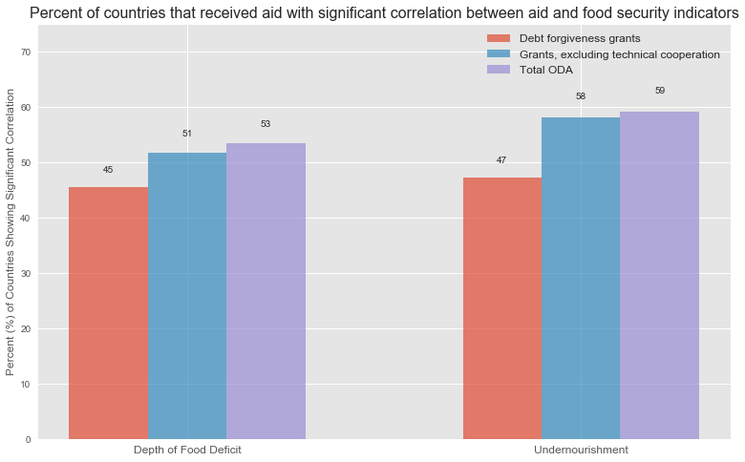

Figure 2‑4. Effectiveness of various aid forms in reducing food security issues

As can be seen from Figure 2‑4, Total ODA correlated with a significant increase or decrease in food security issues for the largest proportion of countries, followed by general grants and debt forgiveness grants. It is clear that debt forgiveness grants are not necessarily the most effective tools in addressing food security issues. A combination of loans and grants should be the preferred method of providing aid to countries, as shown above.

# 3.0 Effect of Economic and Regional Factors on Food security

# 4.0 Impact of Food Security Awareness on Amount of Aid Provided by Donor Countries

# Appendix A – Total ODA vs Undernourishment

# Appendix B – Total ODA vs Food Deficit

# References

Food and Agriculture Organization of the United Nations. (2017). *The State of Food Security and Nutrition in the World 2017.* Rome: Food and Agriculture Organization of the United Nations (FAO).

The World Bank. (2017, 11). *World Bank Open Data*. Retrieved from The World Bank: https://data.worldbank.org/